UECS2103/2403/2423 Operating Systems

Assignment

May 2018

**Group members**

|  |  |  |
| --- | --- | --- |
| **Name** | **Student ID** | **Programme** |
| 1. Tee Wen Seng | 1505408 | SE |
| 2. Lai Zong Hao | 1607246 | SE |
| 3. Eugene Ong Gee Haw | 1704670 | SE |
| 1. Gan Chew Ying | 1505658 | SE |

**Marks breakdown**

|  |  |  |
| --- | --- | --- |
| **Parts** | **Marks** | **Comments** |
| **Part A** |  |  |
| Flowchart | /10 |  |
| Main thread correctness. | /10 |  |
| Detect thread correctness. | /10 |  |
| Drill thread correctness. | /10 |  |
| Clean thread correctness. | /10 |  |
|  |  |  |
| **Part B** |  |  |
| Task description. | /12 |  |
| Task type. | / 6 |  |
| Consequences of failure. | /12 |  |
| **Total** | /80 |  |

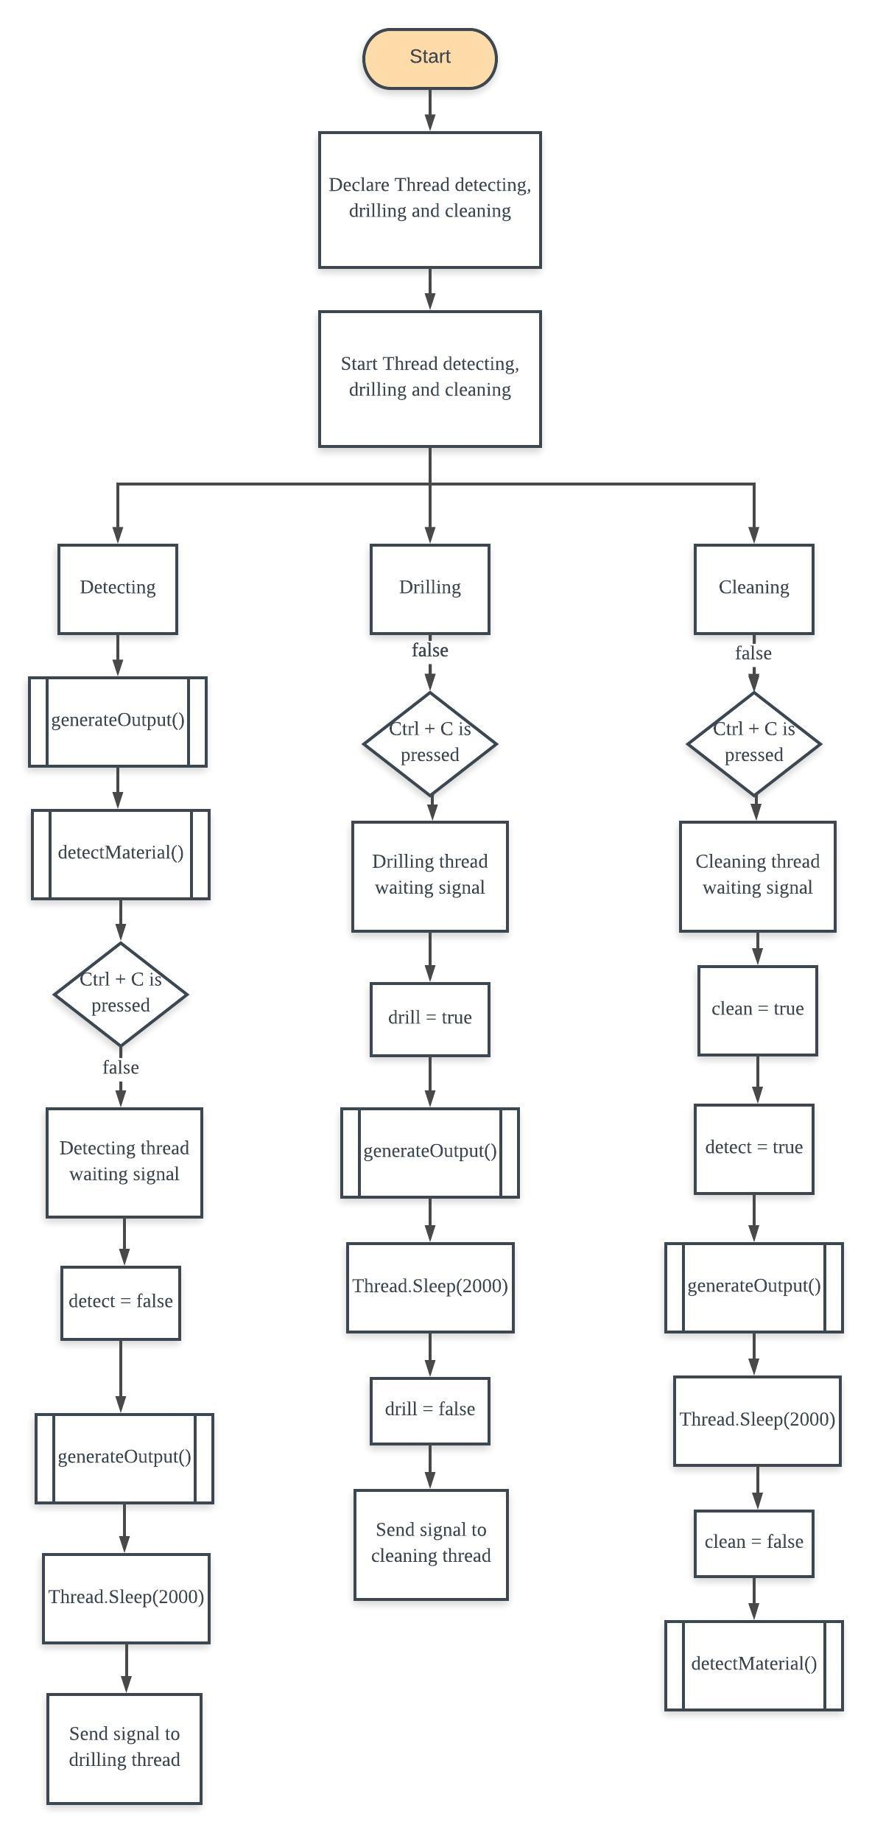

**Part A (Flowchart)**

**Send signal**

detectMaterial() function

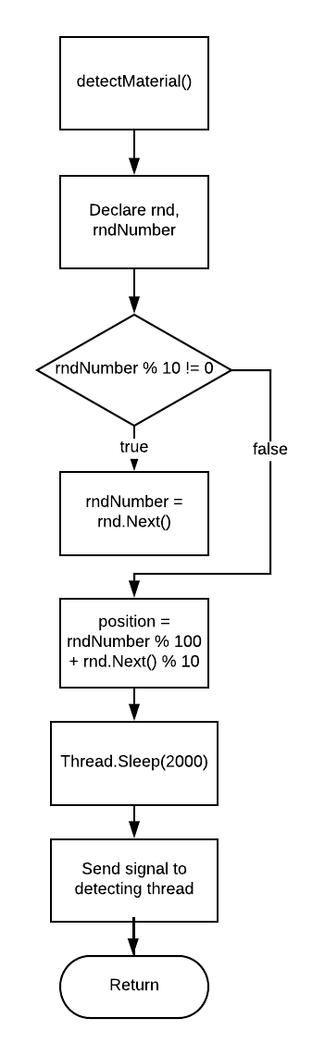

generateOutput()

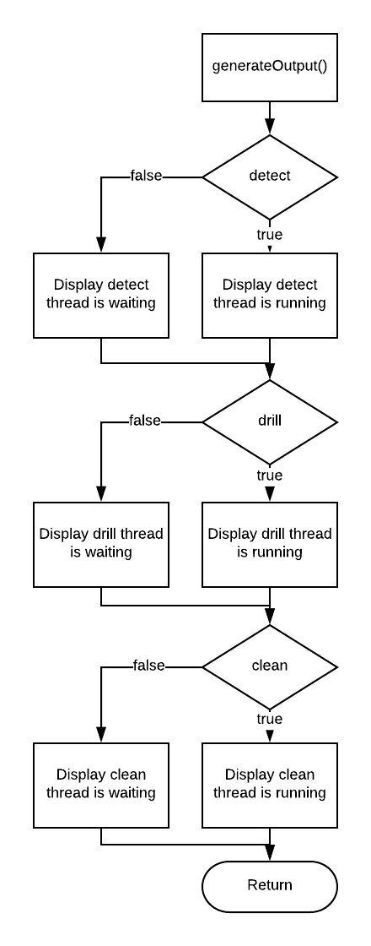

**PART B**

**Introduction**

An autonomous car is a vehicle that is capable of sensing its environment and navigating without human input or manually controlled by human.

It is combine a lot of technology components to perceive their surrounding such as radar, GPS, odometry and computer vision. During the driving process, those components have to continuous collecting the sensory information to detect the surrounding environment to avoid any obstacles and collect pattern or habit of user driving style. Hence, real-time operating system should implement to the control unit of an autonomous car to serve real-time applications that process data as it comes in, typically without buffer delays. The processing time must be done within a fixed time constraints or the system will fail. A real-time system can be categorized according to the consequences of failing to meet timing requirements. Failures can occur because results are not produced within a deadline, or, results are delivered late. For a hard real-time system, if the system fails to meet the deadlines even once, which means it is a given time after a triggering event, by which a response has to be completed, the system considered to have failed. In short, any tasks executing in a hard real-time system must be finished within a fixed time while tasks executing in a soft real-time system will be finished mostly within a fixed time, means that the tasks still continues run but error will occurred.

**i) The safety of passengers**

**Name: Forward Collision Avoidance System**

Task Description

Forward collision avoidance system, a crash-preventing braking system is commonly implemented in most of the autonomous cars. This system’s main purpose is to prevent any imminent collisions with any obstacles infront of it. It uses cameras, radars, lasers or any of the above combinations to detect any obstacles infront of the vehicle. The illustration below shows a basic image of how a forward collision avoidance system works.

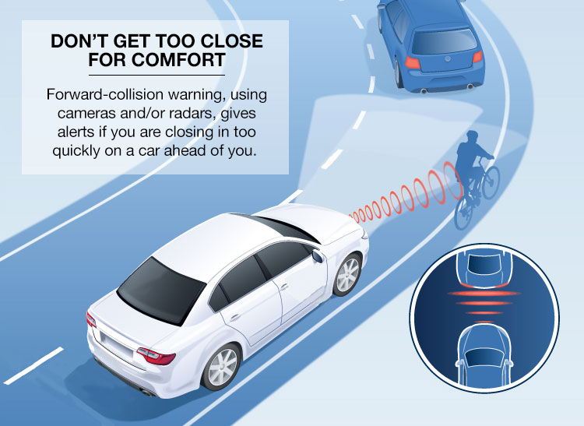

Type of task

This system is a hard real-time task as it requires immediate information collected from the cameras, radars or lasers in order to make split-second decisions to prevent any potential catastrophe. Any jitters or misses in deadlines would potentially cause immense damages to the car or even the passengers itself.

Consequences of task failure

If the forward collision avoidance system in an autonomous car is faulty, it might interpret information such as its car’s speed, the current road’s speed limit and the presence of an incoming obstacle wrongly. All of the above would lead to a potential collision with the obstacle infront of the car, due to the system inability to stop the car in time. Even if the collision is considered to be minor, it would still disrupt the flow of traffic for quite some time. However, if the collision is catastrophic, it would threaten the lives of the passengers not only in the car, but also everyone in the surrounding as well.

**ii) The comfortableness of passengers**

**Name: Speed controlling system**

Task Description

The speed controlling system is implemented is automated vehicle to ensure the car is controlled by the system in a steady range of speed to prevent the passenger from feeling a drastic change in posture during any sudden acceleration which might disturb the comfort of the passenger. The speed controlling system will maintain the vehicle in a stable range of velocity in multiple events involved such as switching to highway or other lanes, moving when the traffic light turns green, or when a car detected infront of a specified distance. The speed controlling system will minimize the acceleration or deceleration to ensure the passenger are always retained in state of healthy posture instead of sudden forward or backward movement due to the effect of inertia which might have a negative effect on parts of our upper body.

Type of task

The speed controlling system should be categorized under hard real time system. The timing constraint should be strict as the failure may indicate serious car accident. The speed of the automated vehicle will change according to the traffic status of the current route and the surrounding obstacles detected. Any acceleration or deceleration above the range set will be detected by the system as an error and the related data will stored in database to further improve the system in the next similar scenario encounter.

Consequences of task failure

If the system failed, the cervical instability or fracture of the passenger may occur due to the sudden acceleration or deceleration of the vehicle. A tragic crashing event may occur with the car surrounding when the system fails to safely switch lanes or sudden movements that are triggered due to incorrect prediction of distance and the speed required to reach a destination.

**iii) Energy consumption**

**Name: Eco-driving system**

Task Description

As for energy consumption, a featured mode in autonomous cars, eco-driving can drastically bring down fuel consumption. Us human drivers may encounter situations where we are influenced by external factors such as emotions, obstacles, or even mistakes when we are driving, thus accelerating or decelerating the vehicle aggressively and unneccesarily may occur, resulting in higher energy wastage. Situations such as long traffic jams and instances of road rage would also contribute to fuel wastage. With the help of eco-driving practices in autonomous cars, like real-life traffic sensing, telematics and behavior mapping, situations that contribute to unnecessary fuel wastage can be prevented, thus ensuring fuel savings. The illustration below shows how all the entities would help the car to be precise in its movement, thus preventing energy wastage.

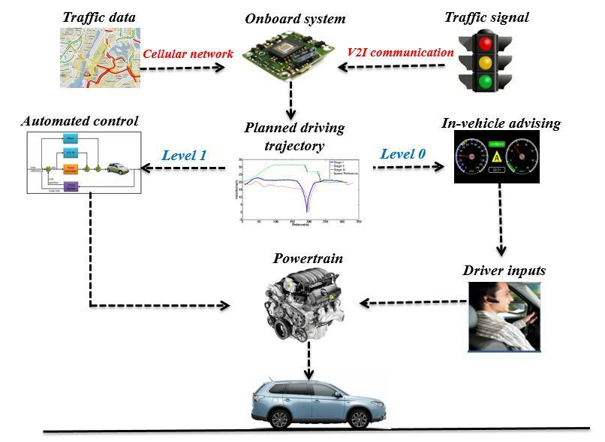

Type of task

Eco-driving would be categorized under the hard real-time task, as it needs to coordinate with the current traffic situations as well as any potential unexpected obstacles on the route it’s taking. The eco-driving system has to be consistent and accurate. Eventhough small misses in the deadlines might not lead to an immense catastrophic traffic accident, these minor lags that might cause the car to not decelerate according to the road’s speed limit for a few seconds or brake half a second late before a red traffic light, would cause unnecessary fuel wastage, even if its just a tiny amount. The fact that it would cause unnecessary fuel wastage already contradicts with the sole purpose of the eco-driving system, which aims to maximize the efficiency of fuel consumption.

Consequences of task failure

The failure of this eco-driving system would cause definitely cause fuel wastage in the car itself. As an autonomous car is driverless, without the help of an eco-driving system, the system would not have to take energy consumption efficienty into consideration, allowing it to make decisions that prioritises other factors, such as its speed and the time taken to reach its destination. Sure, the passenger might reach his or her destination at a faster rate, but the energy consumption of the car would be drastically higher as well. Not only would this cost a fortune for the car’s owner, but, in a bigger picture, if every autonomous cars in the world do not have a built-in eco-driving system, the world’s non renewable energy would be depleted at a faster rate than what we expected.